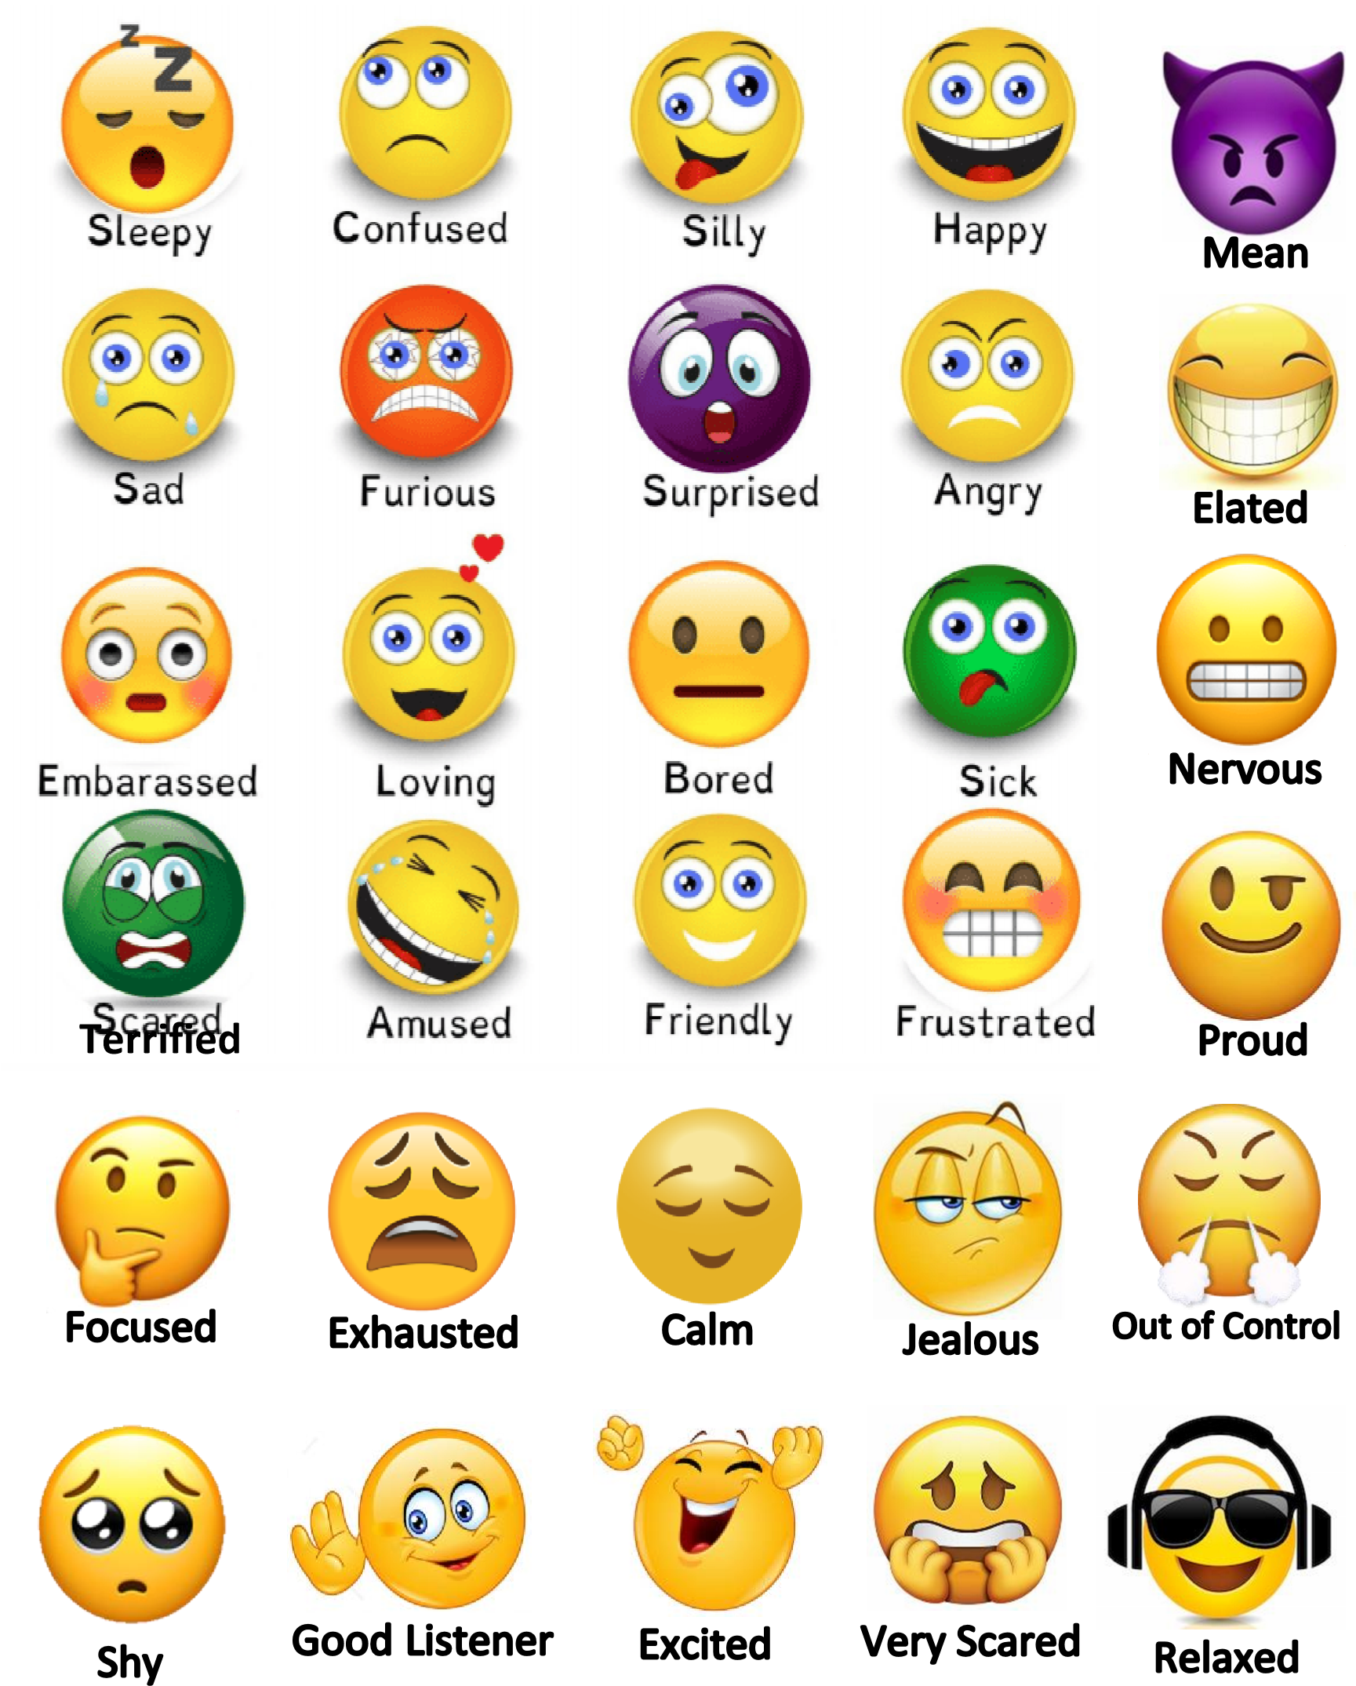

**Sad, Tired, Sleepy, Happy, Excited, Mean, Calm, Peaceful, Silly, Wiggly, Mad, Angry, Good listener, Sick, Proud, Focused, Frustrated, Relaxed, Shy, Loving, out of control, Jealous, Confused, Friendly, Amused, Bored, Terrified, Embarrassed, Prickly, Very scared, Very angry, Offended**



Sick

hausted

Shy

Bored