- These are the co2 emissions from a car over five months.
Circle all the numbers greater than 0.5.
0.7 0.74 0.3 0.9 0.31

- Circle the number closest in value to 0.2.
0.02 0.06 0.22 0.3 0.8

3) Can you order these numbers from smallest to biggest?
1.9 19.01 0.91 91.0 1.91

- Jane went to the store to buy a tyre. The price had fallen down and the digits had become jumbled.
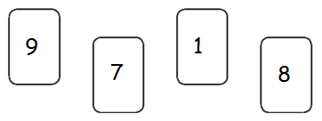

Can you sort these digits so that they make the decimal number nearest to 20?

- Draw a line between the equivalent decimal number and fraction.

0.8 0.50 0.12 0.03 0.003

