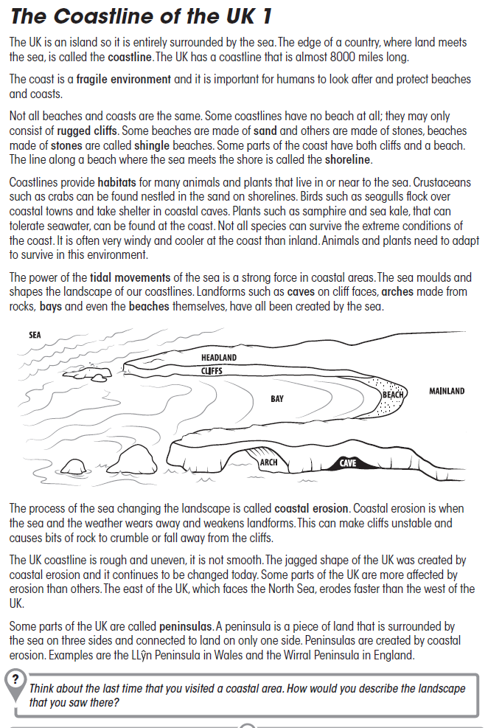

Now answer the following questions:
- What is a coastline?
…
- What two natural materials might beaches be made from?
…
- Choose two animals or plants that are found in coastal areas. Name them and describe why they have a coastal habitat.
Name | Reason

- Name three coastal landforms that have been created by the sea.
…
…
…
- Sketch a diagram showing two of the landforms you have named. Label your landforms clearly.

Draw on the computer and insert or
draw on paper, take a photo and then insert it here

- What is the name of the process that created these landforms?
…
- Which part of the UK is most affected by this process?
…
- Describe what a peninsula is and name an example.
…

