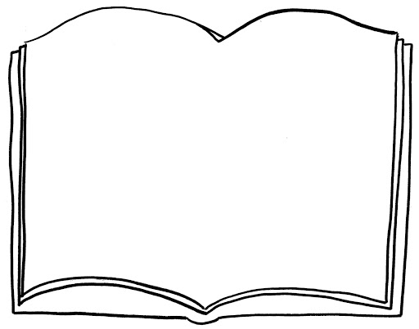
Book Review by:

Author:

Title:

Genre:

Plot – Provide a brief outline of the main story. Are there any plot twists? Did you enjoy the plot?

Characters – Who were the characters? Who was your favourite character? Why?

Your opinion – Which was your favourite part? Explain why.

Comparision – Which character are you most like? How and why?
Which character are you least like? How and why?

Recommendation – Who would you recommend this book to? Explain why.

Your rating (… out of 5 – Remember to give reasons for your choice.

