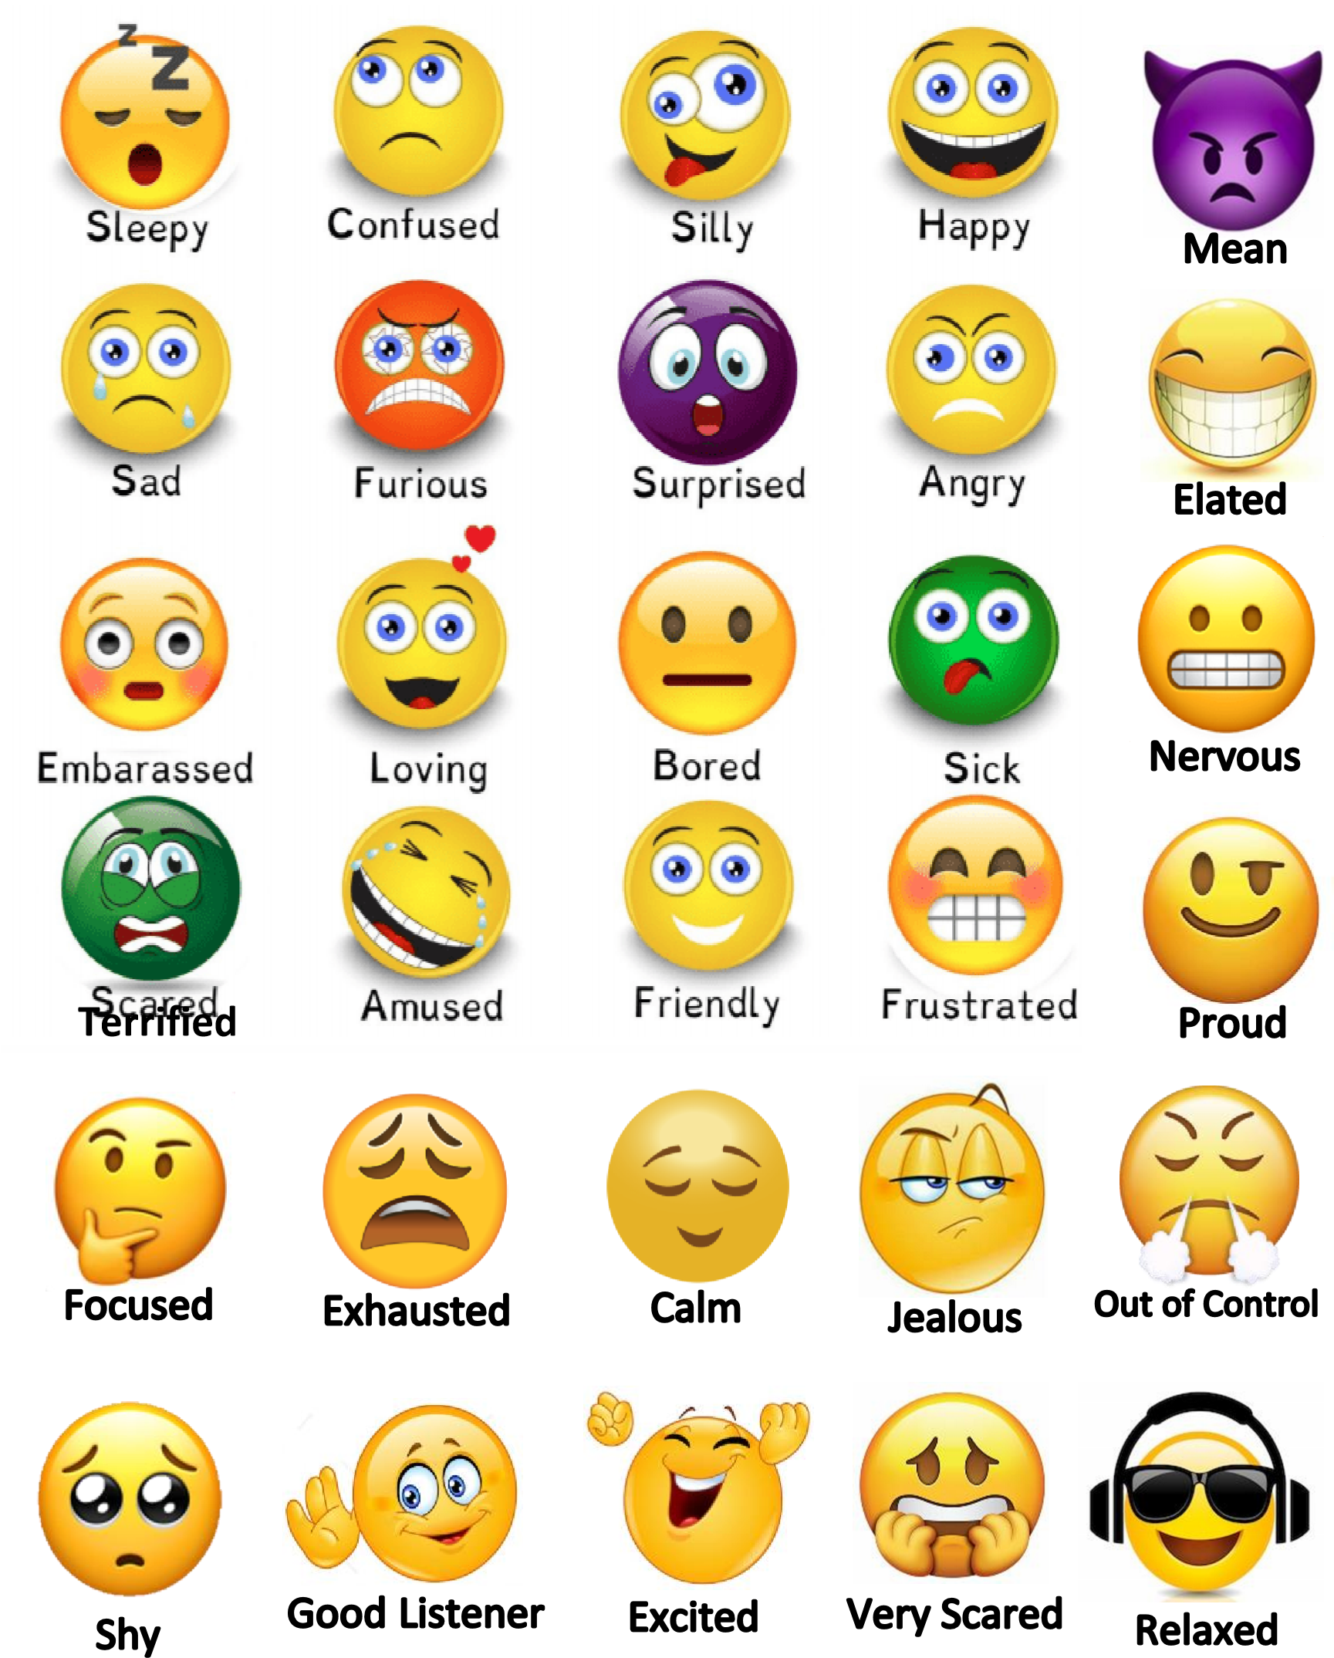

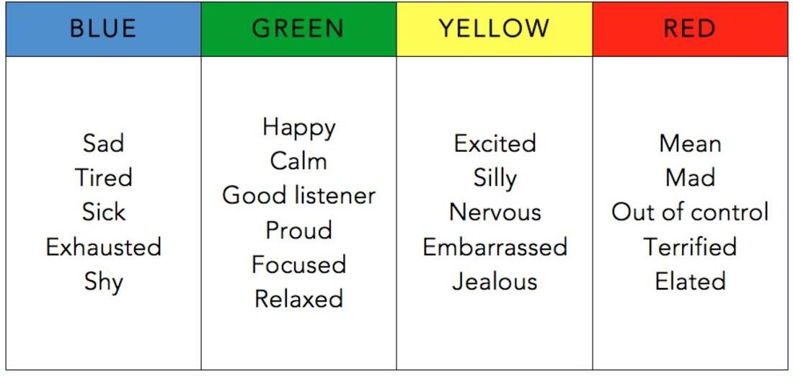

Mean

Mad

/Angry

Furious

Out of Control

Elated

Terrified

Very Scared



Excited

Silly/Wiggly

Nervous

/Anxious

Frustrated

Embarrassed

Jealous

Confused

Amused

Surprised



Happy

Calm

/Peaceful

Good Listener

Proud

Focused

Relaxed

Loving

Fri

e

ndly



Sad

Tired

/Sleepy

Sick

Exhausted

Shy

Bored