Today, I am trying to put the slides into a Word document so that you can change things and don’t have to type everything up. I hope that works better.

A) Starter: Answer these questions in your books.

1. Who was the most powerful god?
2. How could Prometheus be described?
3. How did Zeus punish Prometheus for stealing fire?
4. Who else did Zeus punish?
5. Who helped Zeus to create Pandora and how did they help?
6. Who was given a small box?
7. What came out of the box?
8. Why did Epimetheus need to console Pandora?
9. Why did Pandora and Epimetheus open the box again?
10. Why did hope make a difference in the world?

L.O. I can correctly use the past tense - simple past.
B) Reading the sentences below and correct them.
- On Sunday last week, I swim for an hour.
- Last night, my brother build a rocket with his Lego.
- Yesterday, I see a ghost.
- On Monday he say, "Bring your book to the library!"

C) PRESENT or PAST? Fill in the correct form of the verb.
- Thomas ___________ he’d finished his homework until he saw the second set of questions. (think/thinking/thought)
- Before Dad _________ me home, we go to the supermarket to get something for dinner. (took/taking/takes)
- Yesterday at two, I ___________ in the pool. (swam/was swimming/swims)
- When he visited Wales, he ___________up Mount Snowdon. (climbing/climb/climbed)

L.O. I can correctly use the past tense - simple past.
Remember my initial ideas for innovating the Myth of Pandora?
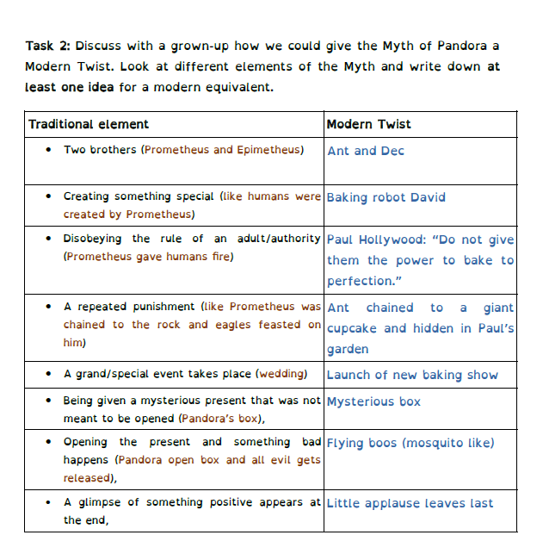

It then had translated into the following story-mountain.
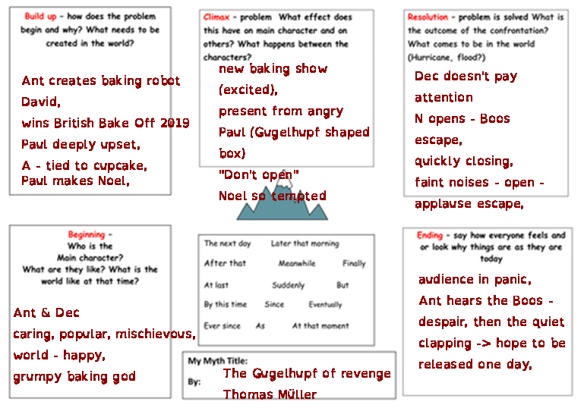

Now, I need to translate this into writing. But first, here are my success-criteria. Your task is to add two success criteria (also write a note on why you chose them).
L.O.: I can use a range of narrative devices to innovate a Greek Myth with a modern twist.
I have used/included ... | I think | My parent thinks | My teacher thinks
- the structural features of a narration (Build-up, problem, resolution, ending),
- the features of a Myth (Gods, Heroes, just/unjust actions by the key personal, motives like revenge or reinstating a balance/the good, ...),
- language for effect (e.g. figurative language)
- ambitious vocabulary
- fronted adverbials
- Subordination (incl. relative clauses)
- speech (direct and reported)
- correct spellings and a range of correct punctuation
- consistent tense (past)
- Add your own one here:
- Add your own one here:

Compare the original with my innovation from the other day.
Then start writing your own modern Myth. Remember to stop after each paragraph and proof-read thoroughly.

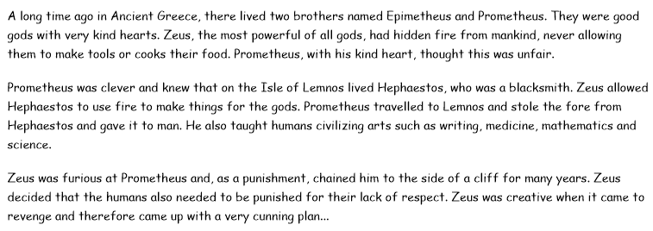

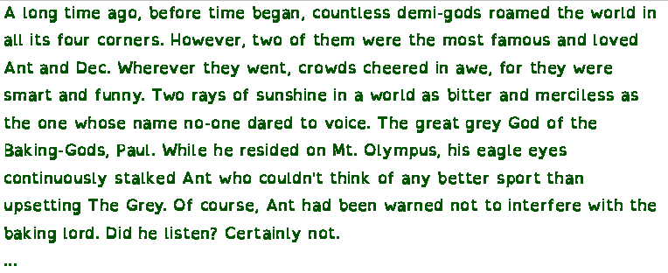
Reflection after each lesson:

A) Analyse your work (product):




B) Reflect on the work-process:
- What when well?
- What do you need to focus on in the future?

---------------------------------------------------------------------------------------------------------

Type your text here …

