L.O.: I can convert between metric and imperial measurements. Date:
Fluency:
1) Complete the conversions. Use the bar model for help.
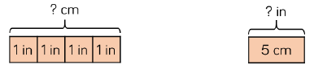
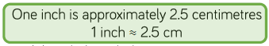

10inches ≈ _________ cm 10cm ≈ _______ inches
16inches ≈ _________ cm 1cm ≈ _______ inches
15inches ≈ _________ cm 5.5cm ≈ _______ inches
33inches ≈ _________ cm

2) Complete the conversions.

2kg ≈ ______ lbs 5kg ≈ ______ lbs
______kg ≈ 22 lbs 55kg ≈ ______ lbs

3) There are 568 millilitres in a pint. How many millilitres are there in …
10 pints | 5 pints | 0.5 pints | 2.5 pints
ml | ml | ml | ml

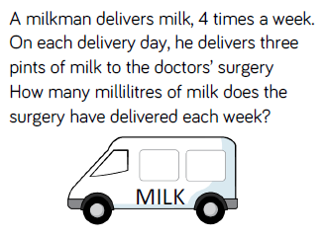
Reasoning
4) Solve and show your workings clearly.

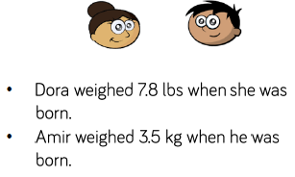
Diving Deeper
5) Who was heavier at birth?
Explain how you know.
_______ kg _______ lb

