L.O.: I can convert between metric measurements (distance) Date:

Introduction:
Write down a guidance on how to convert from …
- mm → cm __________________ cm → mm _________________
- cm → m ___________________ m → cm _________________
- m → km ___________________ km → m _________________

You can create a diagram like this:
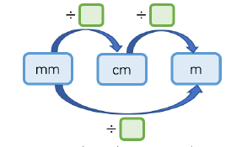

Fluency:

1) Create 3 different towers of books. Measure the height of each tower centimetres

a) ________cm
b) ______cm_
c) ________cm

What is the height difference between the tallest and smallest? __________mm

2) Line A is 5 centimetres long, Line B is 54 millimetres longer than A.
- Draw both lines (First draw a line, then go to properties and change length to 5cm – it’s a bit of ICT learning as well.)
- How long is line B? ___________

3) Complete the table with the height of 4 different people.
 | mm | cm | m
Jim |  | 194
Tess |  | 175
Lui |  | 180
Paul |  | 205

Reasoning
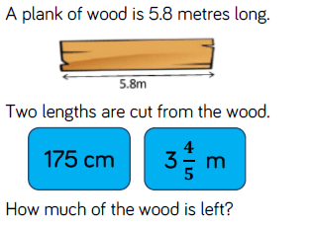
4) Solve and explain clearly.

Diving Deeper
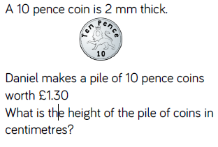
5) Solve and explain how you know.

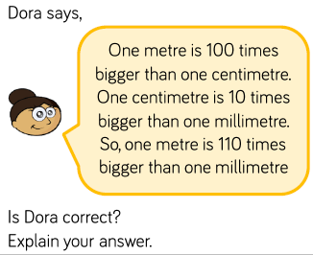
6) Agree or disagree? Explain how you know.

