Greek Myths and a modern twist.

Task 1: Please read the following extract (2 pages) from Percy Jackson and write a list of words, phrases and events that show that this text is linked to a Myth, e.g. lightning bolt (symbol for Zeus), Demi-God, destroying objects with an unimaginable force …

Words linked to Myths | Phrases linked to Myths | Events linked to Myths
________________________________________________________________________________ | ________________________________________________________________________________ | ________________________________________________________________________________
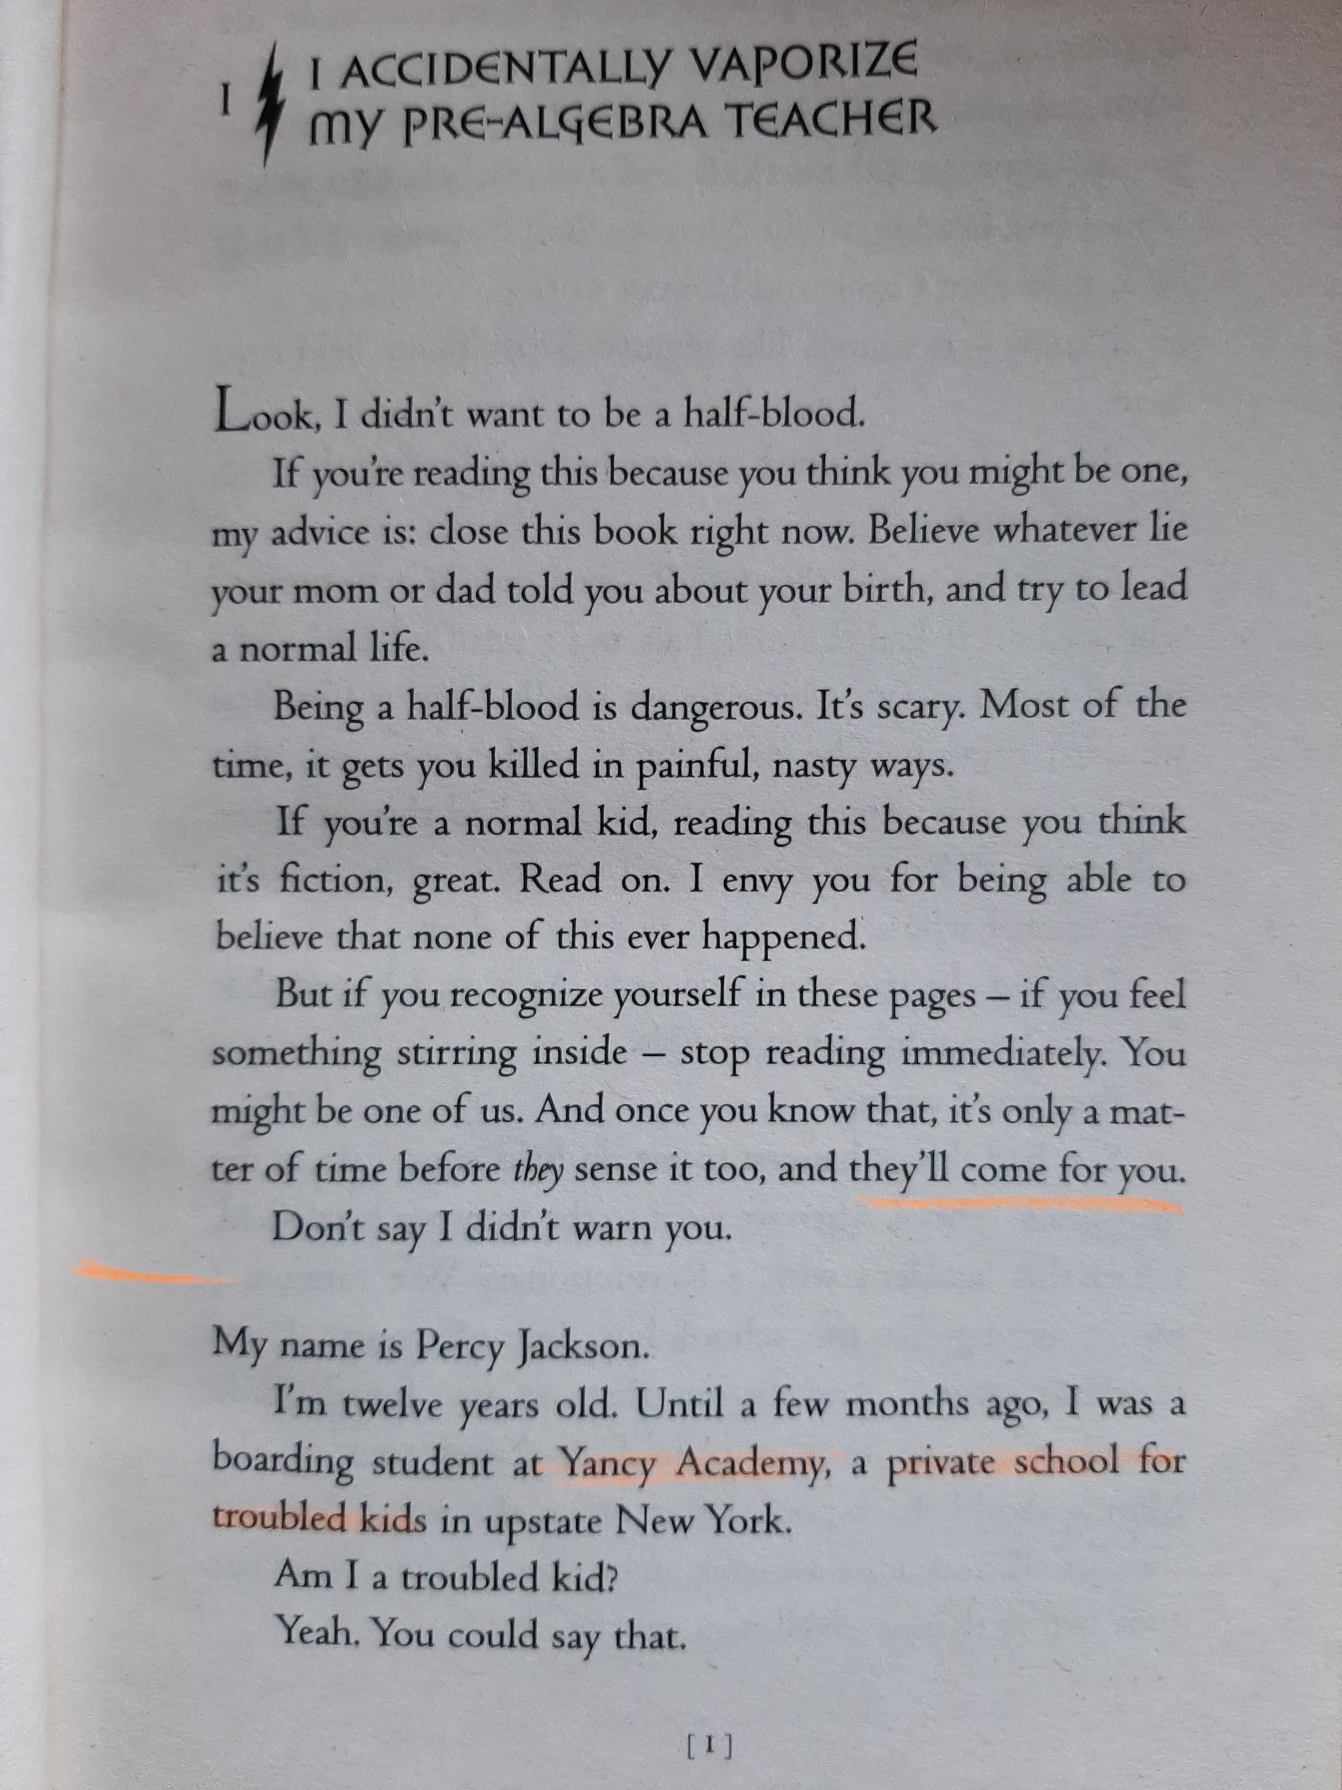

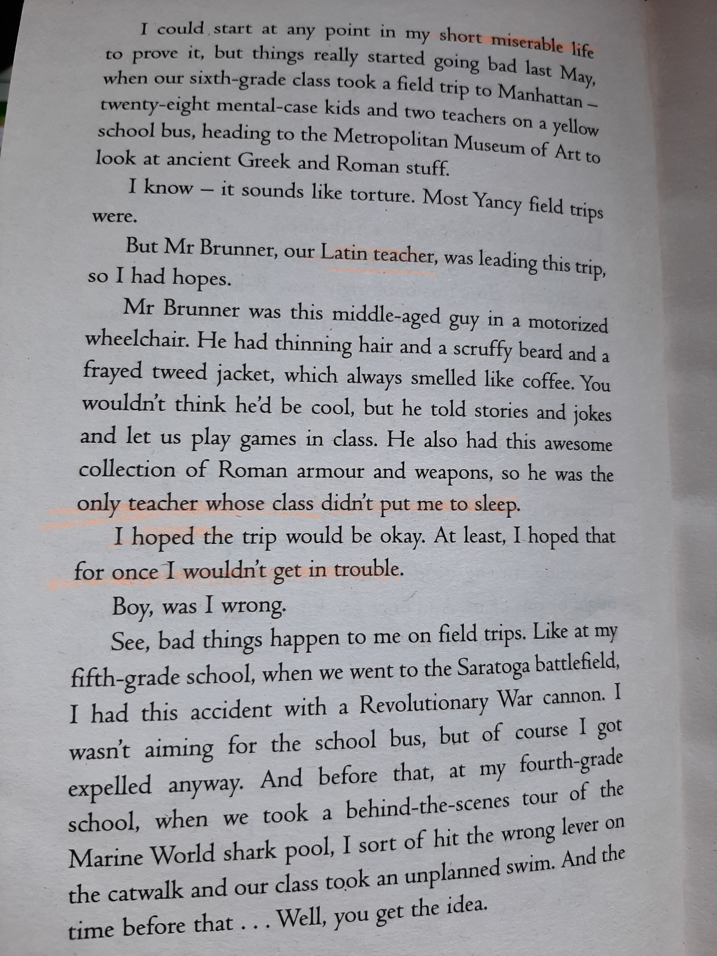

Task 2: Discuss with a grown-up how we could give the Myth of Pandora a Modern Twist. Look at different elements of the Myth and write down at least one idea for a modern equivalent.

Traditional element | Modern Twist
- Two brothers (Prometheus and Epimetheus) | e.g. to best friends
- Creating something special (like humans were created by Prometheus)
- Disobeying the rule of an adult/authority (Prometheus gave humans fire)
- A repeated punishment (like Prometheus was chained to the rock and eagles feasted on him)
- A grand/special event takes place (wedding)
- Being given a mysterious present that was not meant to be opened (Pandora’s box),
- Opening the present and something bad happens (Pandora open box and all evil gets released),
- A glimpse of something positive appears at the end,

Challenge: Imagine you were Percy Jackson, what other 3 adventures could have happened to you that would remind the reader of a Greek Myth.
- One possible idea: While being on a school trip, he found himself and his friends in a mysterious maze. As they moved through it, they saw footsteps of cattle and birds circling in the sky. (How do you think they could have got out?)

