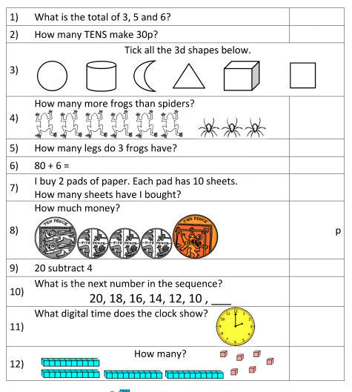

**What time is on this clock?**

**What time would be an hour earlier and later?**