History Mystery
KEY VOCABULARY
deduce – to think carefully about given facts to help you make a decision.
hypothesis – an explanation for something based on given facts which has not been proven.

Can you solve this history mystery using ONLY your brain? (NO INTERNET, NO PARENTS!!)
Step 1: Look at the picture of the object. Jot down any questions you can think of. Use the question words Who, What, Where, When, How, Why to help you.
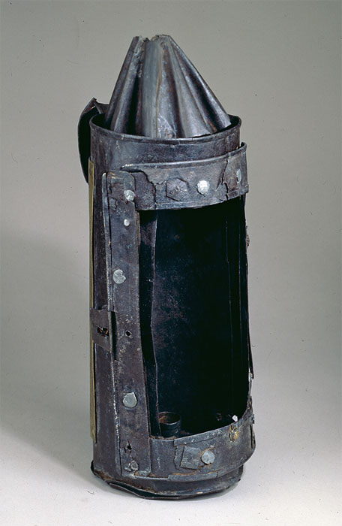

Step 2: Look at each clue, one at a time. After reading the clue, look back at your questions. Has the clue answered any of your questions? Does it present any more questions? Jot these down too before moving on to think about the next clue.

Step 3: When you have looked at all of the clues and your jottings, can you come up with a hypothesis about the object? What have you been able to deduce?
In your hypothesis, you should include:
- What you think the object is and why.
- Who you think the object may have belonged to and why.

The Clues…

CLUE 1
The pointed part at the top is a vent.

CLUE 2
The space inside was designed to hold something used to help in the dark.

CLUE 3
A famous rhyme was written about the owner of this object. It starts with the word, ‘Remember…’

CLUE 4
It belonged to a man who was hung, drawn and quartered, having been convicted of high treason (betraying your country).

CLUE 5
It was found in the Houses of Parliament, London, in November 1605.

