Four-Figure Grid References
40 |  |  |  |  |  |  |  |  | 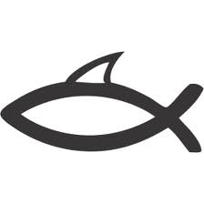
39 |  |  |  |  |  |  |  |  | ⌂  SCH |  | ⌂
38 | ⌂ |  | 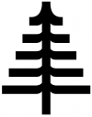  ⌂  ѧ |  | Ѧ  Ѧ  ѧ  ѧ |  |  |  | ⌂  ⌂ |  | 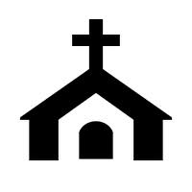 |  | ⌂  ⌂
37 |  |  | ѧ  ⌂ |  | ѧ  ѧ  ѧ  ѧ |  | Ѧѧ  ѧ |  | 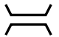 |  | ⌂  ⌂  H  ⌂
36 |  |  | 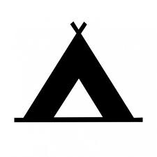 |  |  |  | 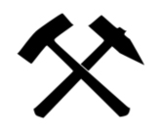
35 |  |  |  |  | 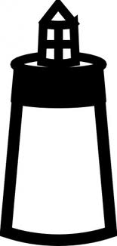 |  |  |  |  |  | ⌂ |  | ѧ
34 |  |  |  |  |  |  |  |  |  |  | ѧ
07 |  | 08 |  | 09 |  | 10 |  | 11 |  | 12 |  | 13 |  | 14

LEGEND
 | Campsite | ⌂ | House |  | Ship |  | Coal Mine |  | Bridge
 | Church | SCH | School |  | Shark | ѧ | Mountain |  | Road
 | Lighthouse | H | Hospital |  | Dolphins |  | Trees |  | River

- Which grid square would you find the following:
  - A bridge: _______________________
  - Hospital: ______________________
  - Lighthouse: ___________________
  - A ship: _______________________
  - Coal mine: ____________________
  - Dolphins: _____________________
- What can be found in the following grid squares:
  - 1139: _________________________________________________________
  - 1140: _________________________________________________________
  - 1236: _________________________________________________________
  - 1238: _________________________________________________________
  - 1334: _________________________________________________________
  - 0838: _________________________________________________________

