6 Figure Grid Reference
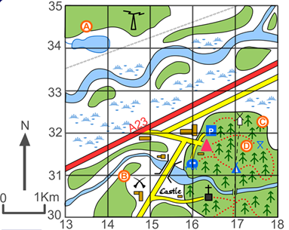

Key
= Church
= Parking
= Coal Mine
= Caravan site
= Windmill

Q1 Give the 6 figure grid reference for

Coal Mine : : _____________________
Parking: _____________________
Castle : ________________________
Church : _________________________
Caravan site: ______________________

Q2 What is at the following grid reference:

164304 = __________________________
143310 = __________________________
172318 = __________________________
171323 = __________________________
Six Figure Grid References
24
23 |  |        |  |  |  |  |  |  |  |  |  |    |  | ■         
22 |  |      |  |            |  |  |  | 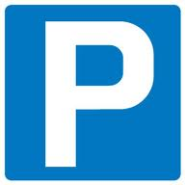    |  |   
21 |  | ϔ  ϔ |  | ϔ  ϔ |  |  |  |  |  |   
20 |  | ■  |  | ■ |  |  |  |   ϔ |  |  |  |  |  | N
19 |  |  |  | ■   |  |  |  | ϔ  ϔ  ϔ |  | ϔ
 | 07 |  | 08 |  | 09 |  | 10 |  | 11 |  | 12 |  | 13 |  | 14

LEGEND
 | Houses |  | Office |  | Courthouse |  | Phone booth | ϔ | Palm tree
 | Church |  | School | 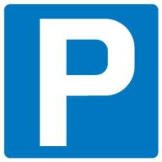 | Car park |  | Hospital |  | Café
 | Post office |  | Bridge |  | Road |  | River |  | Farm land
- a) What is the four figure grid reference of the phone booth? _________________________
b) What is the six figure grid reference of the phone booth? __________________________
- What is the six figure grid reference of the following:
- Hospital: ______________________ e) Cafe: __________________________
- School: _______________________ f) Courthouse: _____________________
- Post office: ____________________ g) Car park: ______________________
- Church: _______________________

