Unwanted Visitors
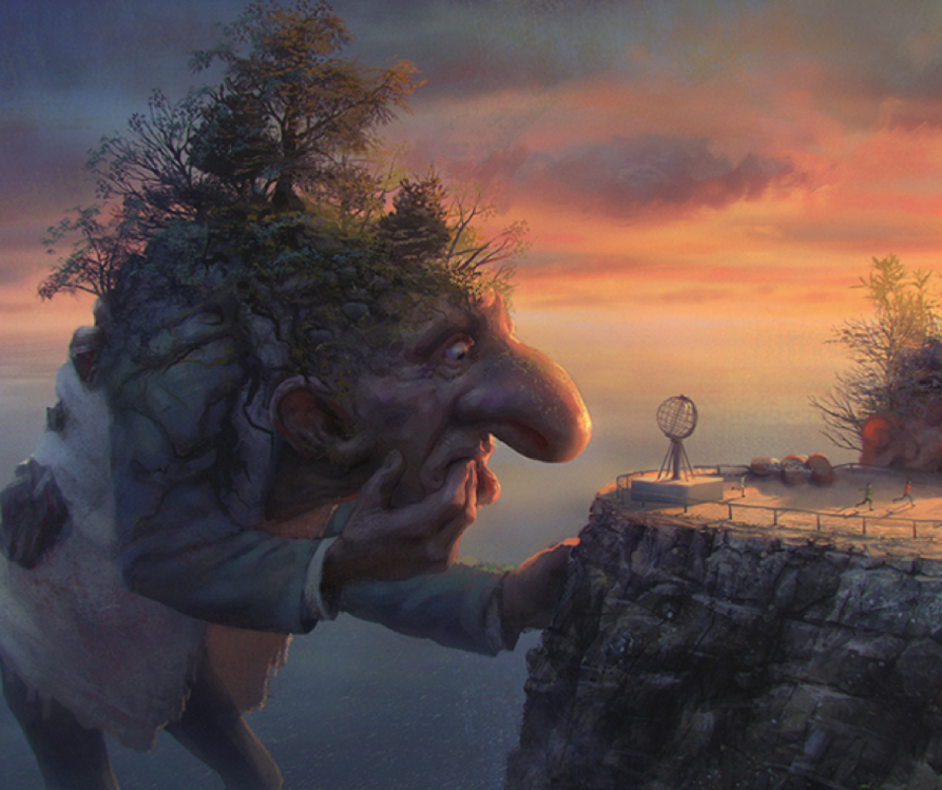

Question time!
Do you think the trolls are friendly or do they pose a threat?
How will people feel about seeing the trolls?
How will the trolls feel about seeing people?
Where do you think the trolls have travelled from?
Why do you think they have come here?
How would you deal with the trolls if you had to?

Sentence challenge!
Can you place the missing bracket in the sentence below?
The troll whose nose was the size of a double decker bus) sneezed, covering people in a blanket of green snot!
Can you use brackets in your writing today?

Story starter!
They had arrived out of the blue, catching everyone completely unaware.
Striding through the vast expanse of ocean as if it were nothing more than a shallow puddle, the trolls provided the gathering crowd on the cliff tops with a menacing spectacle. They were enormous! Grotesque!
The whole cliff shook as one of them crunched a meaty, clumsy hand the size of an elephant into the rock face…
Can you continue the story? Try to describe the trolls’ appearance. Look closely at what’s growing out of their heads!

