The Greatest Library
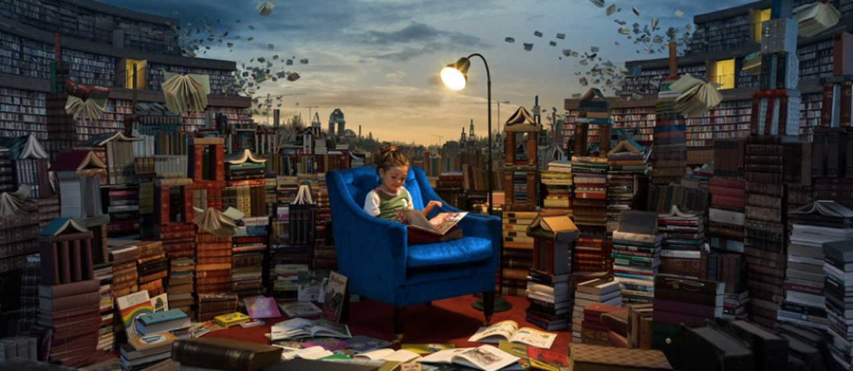

Question time!
How is this library different from a normal library?
What are you favourite types of books?
If you could choose for one of your books to come alive, which one would it be and why?
If you could be a character in a book, who would you like to be?
If you were to borrow every single book from your local library, would it still be a library?
In your opinion, what makes a good book? Can you come up with a top three favourite authors as a class?

Sentence challenge!
Can you use a semi-colon to mark the boundary between independent clauses?
E.g. It was exciting; the books came alive.
This was the most extraordinary library;
Lucy heard a loud bang;

Story starter!
The books had minds of their own…
This was no ordinary library.
Books about knights and castles would gallop all over the library, bravely and boldly ordering the other books around. The books about thieves would sneak around, lurking behind bookshelves in the shadows. Books about wild animals would occasionally roar and bite other books. The ones containing stories set in the winter would often shiver, covering their neighbours with snow and frost.
Lucy loved this place like no other. Reading was the most exciting thing in the world here: everything she read seemed to come alive out of the pages…
Can you continue this story about The Greatest Library?

