Art Time!
Your task: Create a collage inspired by the work of Loui Jover.
What you will need:
- An old magazine
- An old newspaper
- Scissors
- Glue
- Felt tips
Who is Loui Jover?
Loui Jover is an Australian artist who was born in 1967. He uses vintage book pages to create his art, layering different pieces that he has cut out to create a new image, usually of a face or person. He uses different coloured inks to draw over the top. Often the background itself is a newspaper or book page.
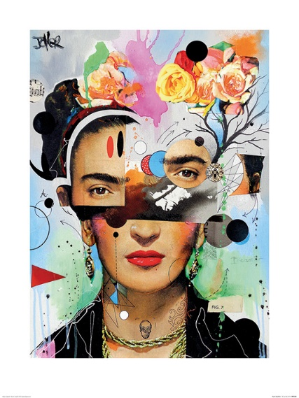
Can you create a portrait using different pieces of magazine and newspaper?
