Reminder about World Book Day-Year Four homework Friday 28th February 2020

Instead of dressing up this year you have been asked to have a go at making one of the following. To help we have made this your homework task for the next two weeks. Please remember to bring it in on Thursday 5th to be put on display. Hopefully, Year Four will have the best displays!
- Extreme reading photos of you reading in usual places or positions.
- Decorate spoon or potato story character
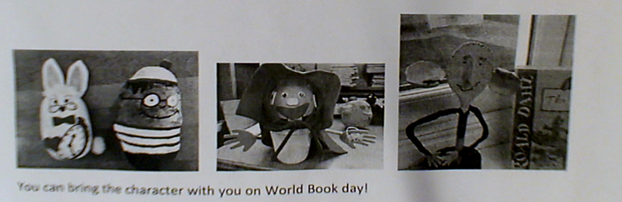
We can’t wait to see your creative ideas.
Come and join us for a free breakfast (whilst you stay and read with your children)

