Welcome to Year 5

Cannon Street Bridge
London Bridge
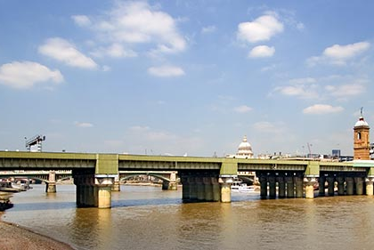

After a hopefully enjoyable, energising and exciting Summer, we warmly welcome you back to school. This year’s team in Year 5 will be: Mr Jalloh and Mrs Thambiayah in London Bridge and Mr Grundey, Mrs Ancel and Miss Marshall in Cannon Street Bridge. Our termly welcome letters and class-blogs will update you on the Curriculum, Trips, Workshops and any other key-dates and information, so please visit them regularly.
Many thanks,
Mr Jalloh, Mr Grundey, Mrs Thambiayah, Mrs Ancel & Miss Marshall
Times-Tables
Homework
Friendly reminders
- Since the Year 5 classrooms are differently located to the rooms in Year 4, we would like to kindly ask you that should you wish to speak to us before school that you do so by making an appointment with the school office or by sending a quick note in your child’s homework diary to see us after school.
- Please remember to frequently check our Year-Group blog to find out about our weekly learning objectives. There, we will also aim to share some of our learning experiences with you.
- Please ensure that your child wears school uniform unless otherwise stated. Also, please ensure that your child has a complete PE kit in school all week. It should be taken home every Friday to be washed. Please check the school’s uniform policy. We are also happy to clarify if you are in doubt.
One of the keys to Mathematical success is knowing multiplication facts! By the end of Year 4, all children at the expected standard in Maths should be able to confidently recall times table facts up to 12 x 12, as well as the inverse (for example 36÷6 = 6).
If your child needs to further secure them, please ensure regular time to practise them. We will test them weekly.
* (check for updates on the class-blogs):
- 13/09/2019 – Science Trip to the National Maritime Museum in Greenwich
- TBC – Art Trip to the Dale Chihuly exhibition at Kew Gardens
- Half-Term break: 21-25 October
- TBC – Science – Rocket exhibition in the school hall
- 13/11/2019 – Into Film Festival excursion
Key-Dates
As you know, homework helps secure and aid the learning in lessons. Therefore, it is crucial that your child completes the set homework on time.
Homework will be set on a Friday to be completed and handed in by the end of Wednesday of the following week. It will consist of: Spellings, English and Maths (weekly).
Please ensure that your child has sufficient time to complete the homework to an excellent standard.
Daily reading – To support the reading development, it is essential that you read with your child daily. We would suggest, you alternate between reading to your child and being read to by your child. Your child must then record the reading (book title & pages read) in the learning diary which we will check daily. When a book is finished, your child will be asked to write a book review which we will keep as evidence to feed into our ongoing assessment.

