Year 4 Christmas Party

Dear Parents/Carers,

We are holding our class Christmas party in the afternoon on Wednesday 19th December. Children are allowed to wear their own clothes to school on this day. Please ensure that children wear suitable footwear.

We will be having games and food in the classroom.

We will supply some squash for your children to drink but please could your child bring a small amount of food to share. We would suggest that Southwark bring sweet treats, such as biscuits or cakes and Millennium bring savoury treats, such as crisps, sandwiches or sausage rolls or fresh fruit.

If your child has a particular dietary need and you would like to provide a snack suitable to their needs, please bring it in a named container and make the class teacher aware.

Please remember to label any food containers so we can return them to you afterwards.
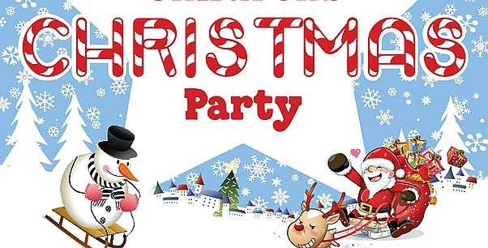
Many thanks,

Miss Danzey and Miss Turpie

